VELAMMAL ENGINEERING COLLEGE SURAPET

2 ND SEMESTER

ELECTRONICS AND COMMUNICATION ENGINEERING

K.MAAALINI

ECE C

ROLL: 43

PHYTHON MINI PROJECT

**TITLE: SCHOOL BILLING SYSTEM**

**AIM:** to perform a program on school billing software.

ABSTRACT ,SOURCE CODE:

from tkinter import *

from tkinter import ttk

import sqlite3

import tkinter.messagebox

from datetime import date

from tkinter import filedialog

import shutil

import os

from tkinter import Text,Tk

#import TkTreectrl as treect

today=date.today()

print ('software is runing......')

firstw=Tk()

firstw.title("APS SCHOOL")

firstw.geometry("1600x1000+0+0")

label=Label(text="APS SCHOOL",font=("times new roman",35),bg="MediumOrchid2")

label.pack(side=TOP ,fill=X)

user1=Label(text="USERNAME",font=("arial",23))

user1.place(x=610,y=120)

user=Entry(width=17,bd=5,font=("arial",20))

user.place(x=570,y=200)

label.pack(side=TOP ,fill=X)

user2=Label(text="PASSWORD",font=("arial",23))

user2.place(x=610,y=280)

user3=Entry(width=17,show="*",bd=5,font=("arial",20))

user3.place(x=570,y=360)

def second():

global secondw

secondw=Tk()

secondw.title("APS SCHOOL")

secondw.geometry("1600x1000+0+0")

def distroy4():

secondw.destroy()

root()

def student():

student1=Tk()

student1.title("STUDENT DETAILS")

def studentid():

rot = Tk()

rot.title("VISITORS")

rot.geometry("1600x1000+0+0")

mainlabel = Label(rot, text="ENQUIRY DETAILS", font=("times new roman", 35), bg="MediumOrchid2")

mainlabel.pack(side=TOP, fill=X)

chat1 = ttk.Treeview(rot,height=20, columns=('name','sur','fee','branch'), selectmode="extended")

chat1.heading('#0', text='ID', anchor=CENTER)

chat1.heading('#1', text=' NAME', anchor=W)

chat1.heading('#2', text='FEES', anchor=W)

chat1.heading('#3', text='COURSE', anchor=W)

chat1.heading('#4', text="LAST NAME", anchor=W)

chat1.column('#1', stretch=YES, minwidth=50, width=100)

chat1.column('#3', stretch=YES, minwidth=100, width=200)

chat1.column('#4', stretch=YES, minwidth=50, width=100)

chat1.column('#2', stretch=YES, minwidth=50, width=100)

chat1.column('#0', stretch=YES, minwidth=50, width=70)

chat1.place(x=470, y=130)

ttk.Style().configure("Treeview", background="black", foreground="coral1")

ttk.Style().configure("Treeview.Heading", background="blue", foreground="palevioletRed1")

rot.configure(background='white')

vsb=ttk.Scrollbar(rot, orient="vertical",command=chat1.yview)

vsb.place(x=1027,y=150,height=400+20)

chat1.configure(yscrollcommand=vsb.set)

conn = sqlite3.connect("abcd12345.db")

with conn:

cur = conn.cursor()

cur.execute('SELECT id ,name, fee , branch,sur FROM kistar ')

for row1 in cur.fetchall():

chat1.insert('', 0, text=row1[0], values=(row1[1] ,row1[2],row1[3],row1[4]))

def viewenquiry2():

rt = Tk()

rt.title("VISITORS")

rt.geometry("1600x1000+0+0")

mainlabel =Label(rt, text="VISITOR", font=("times new roman", 35), bg="MediumOrchid2")

mainlabel.pack(side=TOP, fill=X)

chat1 = ttk.Treeview(rt,height=20 , columns=('EMAIL', 'ENQUIRY', 'DATE'), selectmode="extended")

chat1.heading('#0', text='NAME', anchor=CENTER)

chat1.heading('#1', text='EMAIL', anchor=CENTER)

chat1.heading('#2', text='ENQUIRY', anchor=CENTER)

chat1.heading('#3', text="DATE", anchor=CENTER)

chat1.column('#1', stretch=YES, minwidth=50, width=100)

chat1.column('#3', stretch=YES, minwidth=50, width=100)

chat1.column('#2', stretch=YES, minwidth=50, width=300)

chat1.column('#0', stretch=YES, minwidth=50, width=70)

vsb = ttk.Scrollbar(rt, orient="vertical", command=chat1.yview)

vsb.place(x=955, y=170, height=400 + 20)

chat1.configure(yscrollcommand=vsb.set)

chat1.place(x=400, y=170)

ttk.Style().configure("Treeview", background="#383838", foreground="coral1")

ttk.Style().configure("Treeview.heading", background="blue", foreground="palevioletRed1")

rt.configure(background="white")

conn = sqlite3.connect("abcd12345.db")

with conn:

cur = conn.cursor()

cur.execute('SELECT * FROM golu')

for row in cur.fetchall():

chat1.insert('', 0, text=row[0], values=(row[1], row[2], row[3]))

def distroy5():

secondw.destroy()

window()

mainlabel= Label(secondw,text="APS SCHOOL", font=("times new roman", 35), bg="MediumOrchid2")

mainlabel.pack(side=TOP, fill=X)

button = Button(secondw,width=13, font=("arial", 20), text="REGISTRATION", bg="MediumOrchid2", command=distroy4)

button.place(x=10, y=480)

enquiry = Button(secondw, width=13, font=("arial", 20), text="FEE DETAILS", bg="MediumOrchid2",command=distroy5)

enquiry.place(x=260, y=480)

fee_details = Button(secondw, width=13, font=("arial", 20), text="ENQUIRY", bg="MediumOrchid2",command=enquiry1)

fee_details.place(x=500, y=480)

viewenquiry= Button(secondw, width=13, font=("arial", 20), text="VIEW ENQUIRY", bg="MediumOrchid2",command=viewenquiry2)

viewenquiry.place(x=740, y=480)

viewenquiry1 = Button(secondw, width=13, font=("arial", 20), text="STUDENT ID ", bg="MediumOrchid2",command=studentid)

viewenquiry1.place(x=990, y=480)

def distroy():

firstw.destroy()

def login():

if user.get()=="1" and user3.get()=="1":

second()

distroy()

else:

t = tkinter.messagebox.showinfo("INVALID USERNAME OR PASSWORD ", "YOU HAVE ENTERED INVALID USERNAME OR PASSWORD ")

user.delete(0,END)

user3.delete(0,END)

def root():

root=Tk()

root.geometry("1600x1000+0+0")

root.title("APS SCHOOL")

global entry1

global entry2

global entry3

global entry4

global entry5

global box

global name

global radio1

global radio2

name = StringVar()

global sur

sur = StringVar()

global gander

gander = IntVar()

global var1

var1 = IntVar()

global var2

var2 = IntVar()

global branch

branch = StringVar()

global rollno

rollno = StringVar()

global email

email = StringVar()

global course

course = StringVar()

global python

python = IntVar()

global java

java = IntVar()

global c

c = IntVar()

global d

d = IntVar()

global calculate

calculate = StringVar()

id = IntVar()

search = IntVar()

NAME = name.get()

SUR = sur.get()

EMAIL = email.get()

BRANCH = branch.get()

GANDER = gander.get()

PYTHON = python.get()

JAVA = java.get()

C = c.get()

D = d.get()

CALCULATE = calculate.get()

calculation2 = 2000

label=Label(root,text="REGISTRATION FORM", font=("arial",25), bg="violetred1")

label.pack(side=TOP, fill=X)

label1 =Label(root,text="NAME:", font=("arial",17))

label1.place(x=300, y=150)

label2=Label(root,text="SURNAME:", font=("arial",17))

label2.place(x=300, y=210)

label3=Label(root,text="EMAIL:", font=("arial",17))

label3.place(x=300, y=270)

label3=Label(root,text="GENDER:", font=("arial",17))

label3.place(x=300, y=330)

label4=Label(root,text="BRANCH:", font=("arial",17))

label4.place(x=300, y=390)

label4=Label(root,text="COURSE", font=("arial",17))

label4.place(x=300, y=450)

label4=Label(root,text="TOTAL FEE", font=("arial",17))

label4.place(x=300, y=520)

#==============================entryfield========================================

entry5=Entry( root, textvar=calculate,state="readonly",width=20,font=("arial",15,"bold") ,bd=5)

entry5.place(x=500, y=515)

entry1=Entry(root,bd=5, width=20,textvar=name ,font=("arial",15))

entry1.place(x=500,y=150)

#entry22=Entry(main,bd=5, width=20,textvar=sam ,font=("arial",15))

#entry22.place(x=500,y=150)

entry2=Entry(root,bd=5, width=20, textvar=sur ,font=("arial",15))

entry2.place(x=500,y=210)

entry3=Entry(root,bd=5, width=20,textvar=email ,font=("arial",15))

entry3.place(x=500,y=270)

entry4=Entry(root,bd=5, text="enter roll no.",width=20,textvar=search ,font=("arial",15))

entry4.place(x=800,y=150)

search.set("")

entry4=Entry(root,bd=5, text="enter roll no.",width=20,textvar=search ,font=("arial",15))

entry4.place(x=800,y=150)

#================================radio buttton=======================================

radio1=Radiobutton(root,text="MALE", variable=gander, value=1 ,font=("arial",13))

radio1.place(x=510, y=340)

radio2=Radiobutton(root,text="FEMALE", variable=gander, padx=20, value=0 ,font=("arial",13))

radio2.place(x=570, y=340)

gander.set(3)

#================================droplist======================================

box=ttk.Combobox(root,textvariable= branch,state="readonly", font=("arial",12,"bold"),width=22)

box['values']=['SELECT','COMPUTER SCINCE','MECHANICAL','CIVIL','IT']

box.current(0)

box.place(x=503,y=395)

#===============================checkbutton====================================

checkbutton1=Checkbutton(root,text="JAVA",variable=java)

checkbutton1.place(x=502,y=455 )

checkbutton1=Checkbutton(root,text="C",variable=c)

checkbutton1.place(x=555,y=455 )

checkbutton1=Checkbutton(root,text="C++",variable=d)

checkbutton1.place(x=600,y=455 ,)

checkbutton1=Checkbutton(root,text="PYTHON",variable=python)

checkbutton1.place(x=650,y=455)

python.set(0)

java.set(0)

c.set(0)

d.set(0)

def dis():

root.destroy()

second()

#root.filename=filedialog.askopenfile(initialdir="/",title="select file",filetypes=(("jpeg files","*.jpg"),("all files","*.*")))

#print(root.filename)

#os.chdir('c:\\')

#shutil.move((root.filename),("C:\\Users\\HP\Desktop\\projectgui\\image"))

#=========================buttton==========================

button1=Button(root,text="CALCULATE FEE",width=14,font=("arial",10),bg="indianred1" ,command=calculation)

button1.place(x=530 , y=630)

button12 = Button(root, text="BACK", width=17, font=("arial", 17), bg="indianred1",command=dis )

button12.place(x=0, y=0)

button2=Button(root,text="SUBMIT FORM",width=14,font=("arial",10),bg="indianred1",command= msg )

button2.place(x=660 , y=630)

button3=Button(root,text="RESET",width=14,font=("arial",10),bg="indianred1",command= golu )

button3.place(x=395 , y=630)

button4=Button(root,text="SEARCH",width=14,font=("arial",10),bg="indianred1" ,command=all )

button4.place(x=1100 , y=150)

#button7 = Button(root, text="UPLOAD PHOTO", width=14, font=("arial", 10), bg="indianred1",command=file)

#button7.place(x=1100, y=210)

button4=Button(root,text="UPDATE",width=14,font=("arial",10),bg="indianred1" ,command=update)

button4.place(x=950 , y=630)

button5=Button(root,text="DELETE",width=14,font=("arial",10),bg="indianred1",command=delete )

button5.place(x=800 , y=630)

#button6=Button(root,text="ENQUIRY",width=14,font=("arial",10),bg="indianred1",command=window )

#button6.place(x=300 , y=630)

conn=sqlite3.connect("abcd12345.db")

with conn:

cur=conn.cursor()

cur.execute('CREATE TABLE IF NOT EXISTS kistar(id INTEGER primary key autoincrement ,name text,sur text,email, branch text,gander text, fee int, python int,java int,c int,d int)')

cur.execute("UPDATE SQLITE_SEQUENCE SET seq = 1000 WHERE name = 'kistar'")

cur.execute('CREATE TABLE IF NOT EXISTS golu (NAME TEXT, PHONE INT ,PURPOSE TEXT,DATE)')

cur.execute('CREATE TABLE IF NOT EXISTS FEEINSTALLMENT (id int ,TOTEL FEE INT, REMAIN FEE INT, PAID FEE INT ,INSTALLMENT INT,DATE)')

def ka():

NAMEE=entry23.get()

PHONE=entry24.get()

PURPOSE=box2.get()

conn=sqlite3.connect("abcd12345.db")

with conn:

cur=conn.cursor()

cur.execute('INSERT INTO golu(NAME,PHONE,PURPOSE,DATE)VALUES(?,?,?,?)',(NAMEE,PHONE,PURPOSE,today))

conn.commit()

def r():

j()

ka()

def enquiry1():

enquiry1=Tk()

enquiry1.title("ENQUIRY")

enquiry1.geometry("1600x1000+0+0")

purpose=StringVar()

global entry23

global entry24

global box2

def enquiry1destroy():

enquiry1.destroy()

second()

label22 = Label(enquiry1, text="ENQUIRY", font=("arial", 25), bg="violetred1")

label22.pack(side=TOP, fill=X)

label1 = Label(enquiry1, text="NAME:", font=("arial", 17))

label1.place(x=300, y=150)

label2 = Label(enquiry1, text="PHONE NO.:", font=("arial", 17))

label2.place(x=300, y=210)

label3 = Label(enquiry1, text="PURPOSE:", font=("arial", 17))

label3.place(x=300, y=270)

entry23 = Entry(enquiry1, bd=5, width=20, font=("arial", 15))

entry23.place(x=500, y=150)

button = Button(enquiry1, text="submit", width=30, bg="violetred1", command=r)

button.place(x=500, y=320)

button1=Button(enquiry1, text="<< BACK", width=30, bg="violetred1",command=enquiry1destroy)

button1.place(x=0,y=0)

entry24 = Entry(enquiry1, bd=5, width=20, font=("arial", 15))

entry24.place(x=500, y=210)

box2 = ttk.Combobox(enquiry1, textvariable=purpose, state="readonly", font=("arial", 12, "bold"), width=22)

box2['values'] = ['SELECT', 'TO LEARN PROGRAMMING', 'TO LEARN MACHINE LEARNING', 'FEE DETAILS']

box2.current(0)

box2.place(x=500, y=270)

def cat():

z = IntVar()

FE = entry25.get()

x = entry26.get()

y = entry29.get()

FE=entry25.get()

conn=sqlite3.connect("abcd12345.db")

with conn:

cur=conn.cursor()

cur.execute('SELECT fee FROM kistar WHERE id=?',(FE,))

for row24 in cur.fetchall():

entry26.configure(state="normal")

entry26.delete(0, END)

entry26.insert(0,row24)

entry26.configure(state="disable")

cur.execute(' SELECT SUM(INSTALLMENT) FROM FEEINSTALLMENT WHERE id=? GROUP BY id ', (FE,))

for row23 in cur.fetchall():

entry27.delete(0, END)

entry27.insert(0, row23)

ye = entry27.get()

z = int(float((entry26.get()))) - int(float((entry27.get())))

#cur.execute('INSERT INTO FEEINSTALLMENT(id , TOTAL,INSTALLMENT,PAID ,REMAIN, DATE)VALUES(?,?,?,?,?,?)',(FE, x, y, ye, z, today,))

entry28.configure(state="normal")

entry28.delete(0, END)

entry28.insert(0, z)

print(row23)

entry27.configure(state="disable")

entry26.configure(state="disable")

entry28.configure(state="disable")

conn.commit()

print(x)

print(FE)

print(today)

def reset2():

entry26.configure(state="normal")

entry25.configure(state="normal")

#entry24.configure(state="normal")

entry27.configure(state="normal")

entry28.configure(state="normal")

entry29.configure(state="normal")

entry26.delete(0,END )

entry25.delete(0, END)

entry27.delete(0,END)

entry28.delete(0,END)

entry29.delete(0,END)

#box2.set("SELECT")

entry27.configure(state="disable")

entry26.configure(state="disable")

entry28.configure(state="disable")

def fee_add():

z=IntVar()

FE=entry25.get()

x=entry26.get()

y=entry29.get()

entry27.configure(state="normal")

entry28.configure(state="normal")

entry26.configure(state="normal")

cur.execute('INSERT INTO FEEINSTALLMENT(id , TOTEL,INSTALLMENT, DATE)VALUES(?,?,?,?)', (FE, x,y, today,))

cur.execute(' SELECT SUM(INSTALLMENT) FROM FEEINSTALLMENT WHERE id=? GROUP BY id ',(FE,))

for row23 in cur.fetchall():

entry27.delete(0,END)

entry27.insert(0,row23)

ye=entry27.get()

z=int(float((entry26.get())))-int(float((entry27.get())))

cur.execute('UPDATE FEEINSTALLMENT SET PAID=? WHERE id=?' , (ye,FE,))

cur.execute('UPDATE FEEINSTALLMENT SET REMAIN=? WHERE id=?',(z,FE,))

entry28.configure(state="normal")

entry28.delete(0,END)

entry28.insert(0,z)

print(row23)

entry27.configure(state="disable")

entry26.configure(state="disable")

entry28.configure(state="disable")

conn.commit()

print(x)

print(FE)

print(today)

def installment2():

if int(entry29.index("end"))>int(0):

fee_add()

else:

x=tkinter.messagebox.showinfo("NO FEE ADDED","YOU HAVE NOT ADDED ANY FEE ")

def j():

PURPOSE=box2.get()

print(PURPOSE)

def r():

j()

ka()

def window():

global main

global namee

global phone

global purpose

global entry23

global entry24

global entry25

global entry26

global entry27

global entry28

global box2

global key

global fee3

global KEY

global ley

global sey

global ADDFEE

global entry29

#entry29=IntVar()

#entry26=IntVar()

#entry27=IntVar()

#key=StringVar()

#fee3=StringVar()

#ADDFEE=IntVar()

main=Tk()

main.geometry("1600x1000+0+0")

main.title("enqiry")

namee=StringVar()

phone=IntVar()

purpose=StringVar()

fe=StringVar()

key=IntVar()

ley=StringVar()

sey=StringVar()

#NAMEE=namee.get()

#PHONE=phone.get()

#PURPOSE=purpose.get()

def distroy3():

main.destroy()

second()

button = Button(main, text="BACK", width=30, bg="violetred1", command=distroy3)

button.place(x=0, y=0)

label3=Label(main,text="ENTER STUDENT ID", font=("arial",17))

label3.place(x=400, y=100)

button22=Button(main,text="LOGIN",width=26,font=("arial",10),bg="indianred1",command=cat )

button22.place(x=400, y=310)

button23=Button(main,text="ADD FEE",width=26,font=("arial",10),bg="indianred1",command=installment2 )

button23.place(x=650 , y=310)

entry29=Entry(main,bd=5, width=20 ,font=("arial",15))

entry29.place(x=650,y=200)

button28 = Button(main, text="RESET", width=26, font=("arial", 10), bg="indianred1", command=reset2)

button28.place(x=1150,y=0)

label31=Label(main,text="TOTAL FEE", font=("arial",17))

label31.place(x=900, y=550)

label32=Label(main,text="PAID FEE", font=("arial",17))

label32.place(x=600, y=550)

label33=Label(main,text="REMAIN FEE", font=("arial",17))

label33.place(x=300, y=550)

entry25=Entry(main,bd=5, width=20 ,font=("arial",15))

entry25.place(x=400,y=200)

entry26=Entry(main,bd=5, width=20 ,font=("arial",15))

entry26.place(x=900,y=600)

entry27=Entry(main,bd=5, width=20 ,font=("arial",15))

entry27.place(x=600,y=600)

entry28=Entry(main,bd=5, width=20 ,font=("arial",15))

entry28.place(x=300,y=600)

#entry27=Entry(main,bd=5,textvariable=fee3, state="readonly", width=20 ,font=("arial",15))

#entry27.place(x=960,y=400)

#entry28=Entry(main,bd=5, width=20 ,font=("arial",15))

#entry28.place(x=900,y=400)

#=====================================define charecter=====================

#==================================function==============================

calculation2=2000

def calculation():

NAME = entry1.get()

SUR = entry2.get()

EMAIL = entry3.get()

BOX = box.get()

GANDER = gander.get()

PYTHON = python.get()

JAVA = java.get()

C = c.get()

D = d.get()

print(PYTHON)

print(GANDER)

CALCULATE = calculate.get()

if NAME==("") and SUR==("")and EMAIL==("") and BOX==("SELECT") and GANDER==(3) and JAVA==(0) and PYTHON==(0) and C==(0) and D==(0):

kal=tkinter.messagebox.showinfo(" DETAILS INVALID","FILL ALL THE DETAILS")

else:

global x

if box.get()=="COMPUTER SCINCE" and gander.get()==0:

x=(calculation2-calculation2*20/100)

entry5.configure(state="normal")

entry5.delete(0,END)

entry5.insert(0,x)

entry5.configure(state="disable")

if box.get()=="COMPUTER SCINCE" and gander.get()==1:

x=(calculation2-calculation2*10/100)

entry5.configure(state="normal")

entry5.delete(0, END)

entry5.insert(0, x)

entry5.configure(state="disable")

if box.get()=="MECHANICAL" and gander.get()==1:

x=(calculation2)

entry5.configure(state="normal")

entry5.delete(0, END)

entry5.insert(0, x)

entry5.configure(state="disable")

if box.get()=="MECHANICAL" and gander.get()==0:

x=(calculation2-calculation2*10/100)

entry5.configure(state="normal")

entry5.delete(0, END)

entry5.insert(0, x)

entry5.configure(state="disable")

if box.get()=="IT" and gander.get()==0:

x=(calculation2-calculation2*10/100)

entry5.configure(state="normal")

entry5.delete(0, END)

entry5.insert(0, x)

entry5.configure(state="disable")

if box.get()=="CIVIL" and gander.get()==1:

x=(calculation2)

entry5.configure(state="normal")

entry5.delete(0, END)

entry5.insert(0, x)

entry5.configure(state="disable")

if box.get()=="CIVIL" and gander.get()==0:

x=(calculation2-calculation2*10/100)

entry5.configure(state="normal")

entry5.delete(0, END)

entry5.insert(0, x)

entry5.configure(state="disable")

def msg():

if branch.get()=="SELECT" or gander.get()==3 or ( python.get()==0 and java.get==0 and c.get()==0 and d.get()==0):

calculate.set("PLESE FILL ALL")

if "@" and ".com" not in entry3.get() :

kal=tkinter.messagebox.showinfo(" INVALID DETAILS","ENTER VALID EMAIL ADDRESS")

entry3.delete(0,END)

else:

msg=tkinter.messagebox.askyesno("Form filling confarmation"," WARNING: All data will be erase after 'YES' for new applicant" )

if msg>0:

NAME=entry1.get()

SUR=entry2.get()

EMAIL=entry3.get()

BRANCH=box.get()

GANDER=gander.get()

PYTHON=python.get()

JAVA=java.get()

C=c.get()

D=d.get()

CALCULATE=calculate.get()

conn=sqlite3.connect("abcd12345.db")

with conn:

cur=conn.cursor()

cur.execute('INSERT INTO kistar (name,sur, email, branch, gander,fee ,python,java,c,d ) VALUES(?,?,?,?,?,?,?,?,?,?)',(NAME,SUR,EMAIL,BRANCH,GANDER,CALCULATE,PYTHON,JAVA,C,D,))

golu()

def golu():

entry1.delete(0,END)

entry2.delete(0,END)

entry3.delete(0,END)

box.set("SELECT")

gander.set(3)

python.set(0)

java.set(0)

c.set(0)

d.set(0)

calculate.set("")

entry4.delete(0,END)

def search_id():

SEARCH=entry4.get()

conn=sqlite3.connect("abcd12345.db")

with conn:

cur=conn.cursor()

cur.execute('SELECT name FROM kistar WHERE id=?',(SEARCH,))

for row1 in cur.fetchone():

name.set(row1)

def search_sur():

SEARCH=entry4.get()

conn=sqlite3.connect("abcd12345.db")

with conn:

cur=conn.cursor()

cur.execute('SELECT sur FROM kistar WHERE id=?',(SEARCH,))

for row2 in cur.fetchone():

sur.set(row2)

def search_email():

SEARCH=entry4.get()

conn=sqlite3.connect("abcd12345.db")

with conn:

cur=conn.cursor()

cur.execute('SELECT email FROM kistar WHERE id=?',(SEARCH,))

for row3 in cur.fetchone():

email.set(row3)

def search_branch():

SEARCH=entry4.get()

conn=sqlite3.connect("abcd12345.db")

with conn:

cur=conn.cursor()

cur.execute('SELECT branch FROM kistar WHERE id=?',(SEARCH,))

for row4 in cur.fetchone():

branch.set(row4)

def search_gander():

SEARCH=entry4.get()

conn=sqlite3.connect("abcd12345.db")

with conn:

cur=conn.cursor()

cur.execute('SELECT gander FROM kistar WHERE id=?',(SEARCH,))

for row5 in cur.fetchone():

gander.set(row5)

def search_course():

SEARCH=entry4.get()

conn=sqlite3.connect("abcd12345.db")

with conn:

cur=conn.cursor()

cur.execute('SELECT python FROM kistar WHERE id=?',(SEARCH,))

for row6 in cur.fetchone():

python.set(row6)

cur.execute('SELECT java FROM kistar WHERE id=?',(SEARCH,))

for row7 in cur.fetchone():

java.set(row7)

cur.execute('SELECT c FROM kistar WHERE id=?',(SEARCH,))

for row8 in cur.fetchone():

c.set(row8)

cur.execute('SELECT d FROM kistar WHERE id=?',(SEARCH,))

for row9 in cur.fetchone():

d.set(row9)

cur.execute('SELECT fee FROM kistar WHERE id=?',(SEARCH,))

for row10 in cur.fetchone():

calculate.set(row10)

def update():

box1=tkinter.messagebox.askyesno("CONFARMATION","if you update you will be unable to see previous data again")

if box1>0:

SEARCH=entry4.get()

NAME=entry1.get()

SUR=entry2.get()

EMAIL=entry3.get()

BRANCH=box.get()

GENDER=gander.get()

FEE=calculate.get()

PYTHON=python.get()

JAVA=java.get()

C=c.get()

D=d.get()

CALCULATE=entry5.get()

conn=sqlite3.connect("abcd12345.db")

with conn:

cur=conn.cursor()

cur.execute('UPDATE kistar SET name=? WHERE id=?',(NAME,SEARCH,))

cur.execute('UPDATE kistar SET sur=? WHERE id=?',(SUR,SEARCH,))

cur.execute('UPDATE kistar SET email=? WHERE id=?',(EMAIL,SEARCH,))

cur.execute('UPDATE kistar SET branch=? WHERE id=?',(BRANCH,SEARCH,))

cur.execute('UPDATE kistar SET gander=? WHERE id=?',(GENDER,SEARCH,))

cur.execute('UPDATE kistar SET fee=? WHERE id=?',(FEE,SEARCH,))

cur.execute('UPDATE kistar SET python=? WHERE id=?',(PYTHON,SEARCH,))

cur.execute('UPDATE kistar SET java=? WHERE id=?',(JAVA,SEARCH,))

cur.execute('UPDATE kistar SET c=? WHERE id=?',(C,SEARCH,))

cur.execute('UPDATE kistar SET d=? WHERE id=?',(D,SEARCH,))

conn.commit()

def delete():

box=tkinter.messagebox.askyesno("WARNING","DATA WILL NOT BE RECOVER AGAIN")

if box>0:

SEARCH=search.get()

NAME=name.get()

SUR=sur.get()

EMAIL=email.get()

BRANCH=branch.get()

GENDER=gander.get()

PYTHON=python.get()

JAVA=java.get()

C=c.get()

D=d.get()

CALCULATE=calculate.get()

else:

conn=sqlite3.connect("abcd12345.db")

with conn:

cur=conn.cursor()

cur.execute("DELETE FROM kistar WHERE id=?",(SEARCH,))

conn.commit()

golu()

def all():

search_id()

search_sur()

search_email()

search_branch()

search_gander()

search_course()

INQUIRY=Button(text="LOGIN",width=17,font=("arial",20),bg="MediumOrchid2",command=login )

INQUIRY.place(x=560 , y=480)

firstw.mainloop()

OUTPUT:

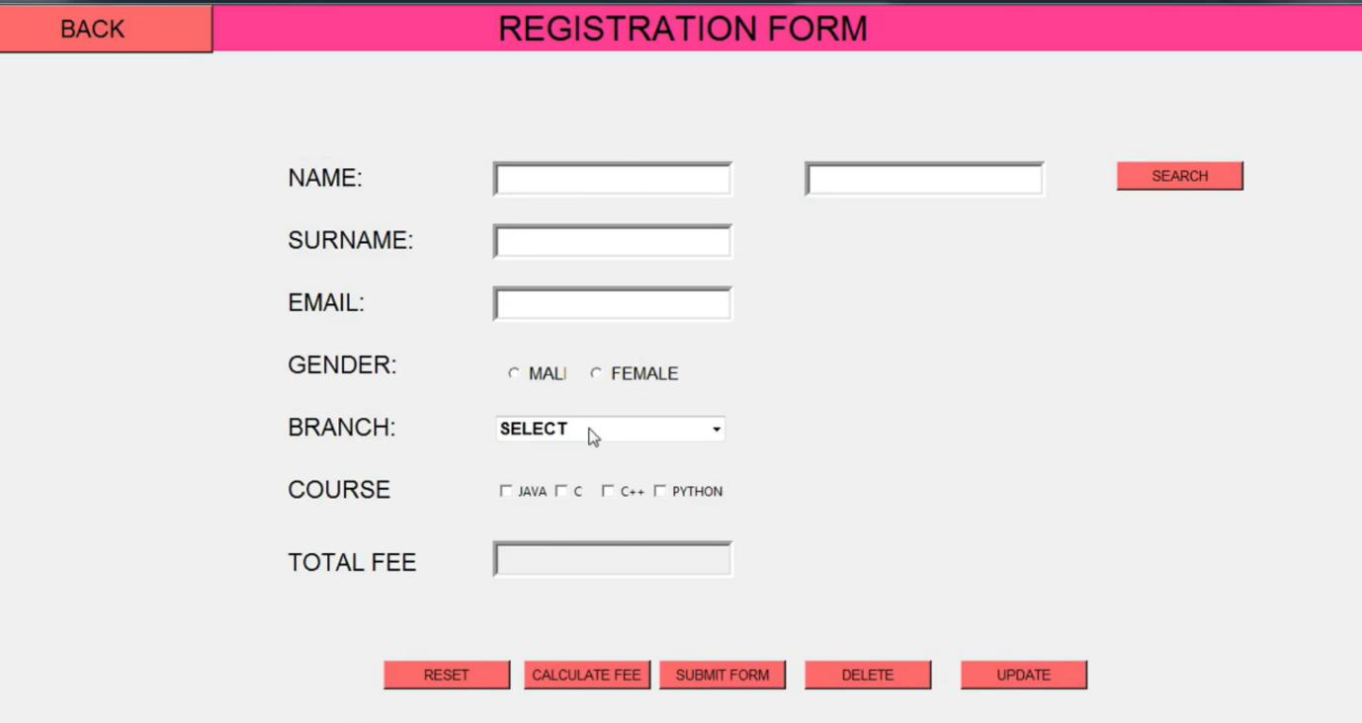

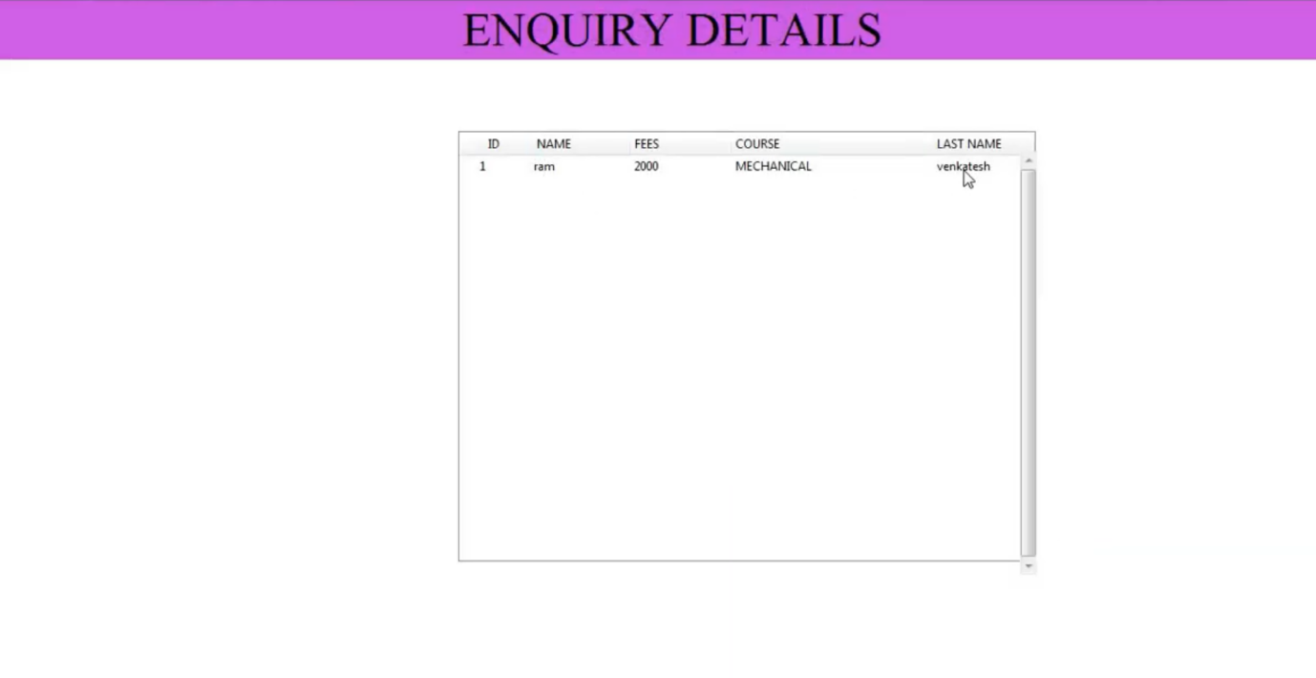

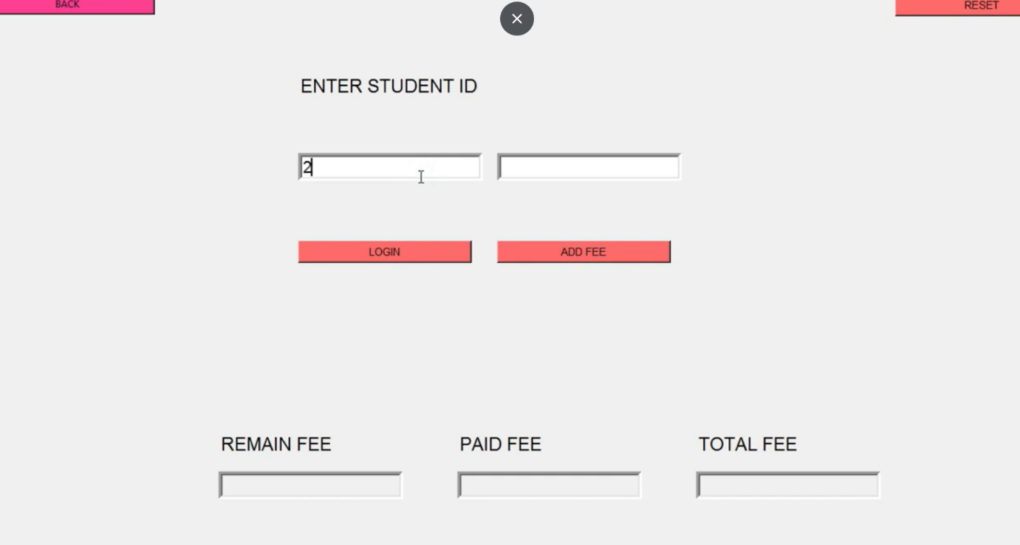

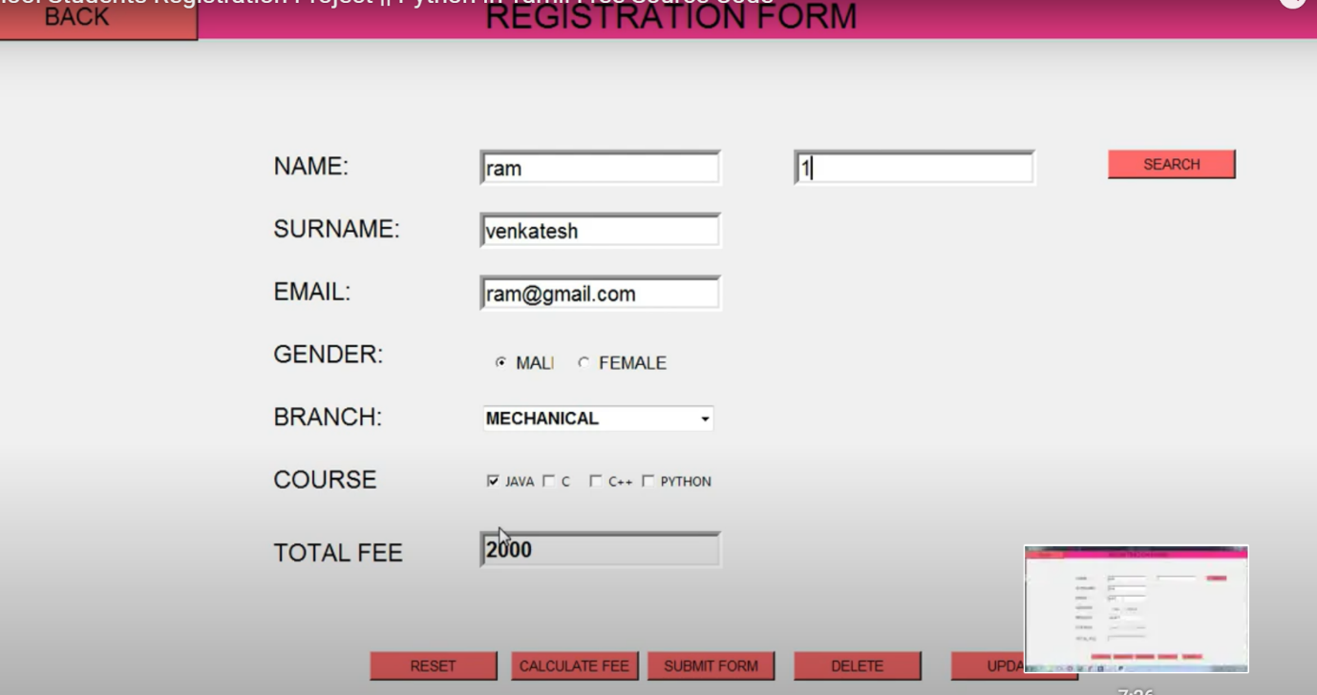

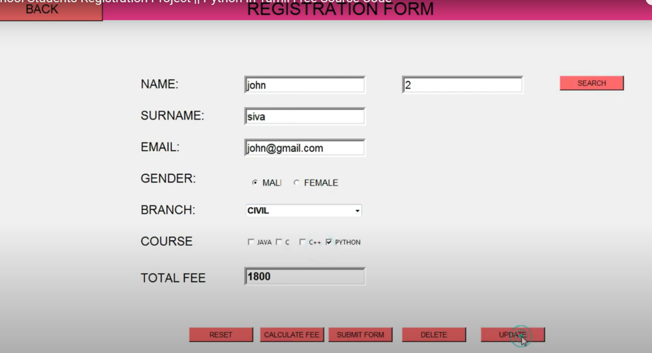

RESULT:

Thus the program for school billing system is excecuted and output is verified.